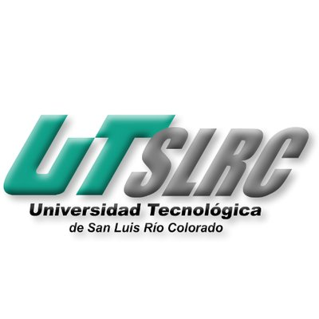

**UNIVERSIADAD TECNOLÓGICA DE**

**SAN LUIS RIO COLORADO**

**MTRA. YESENIA CORAL FLORE FLORES**

**AUTOR: VICTOR MANUEL GALVAN COVARRUBIAS**

San Luis Rio Colorado, Sonora Marzo, 2020

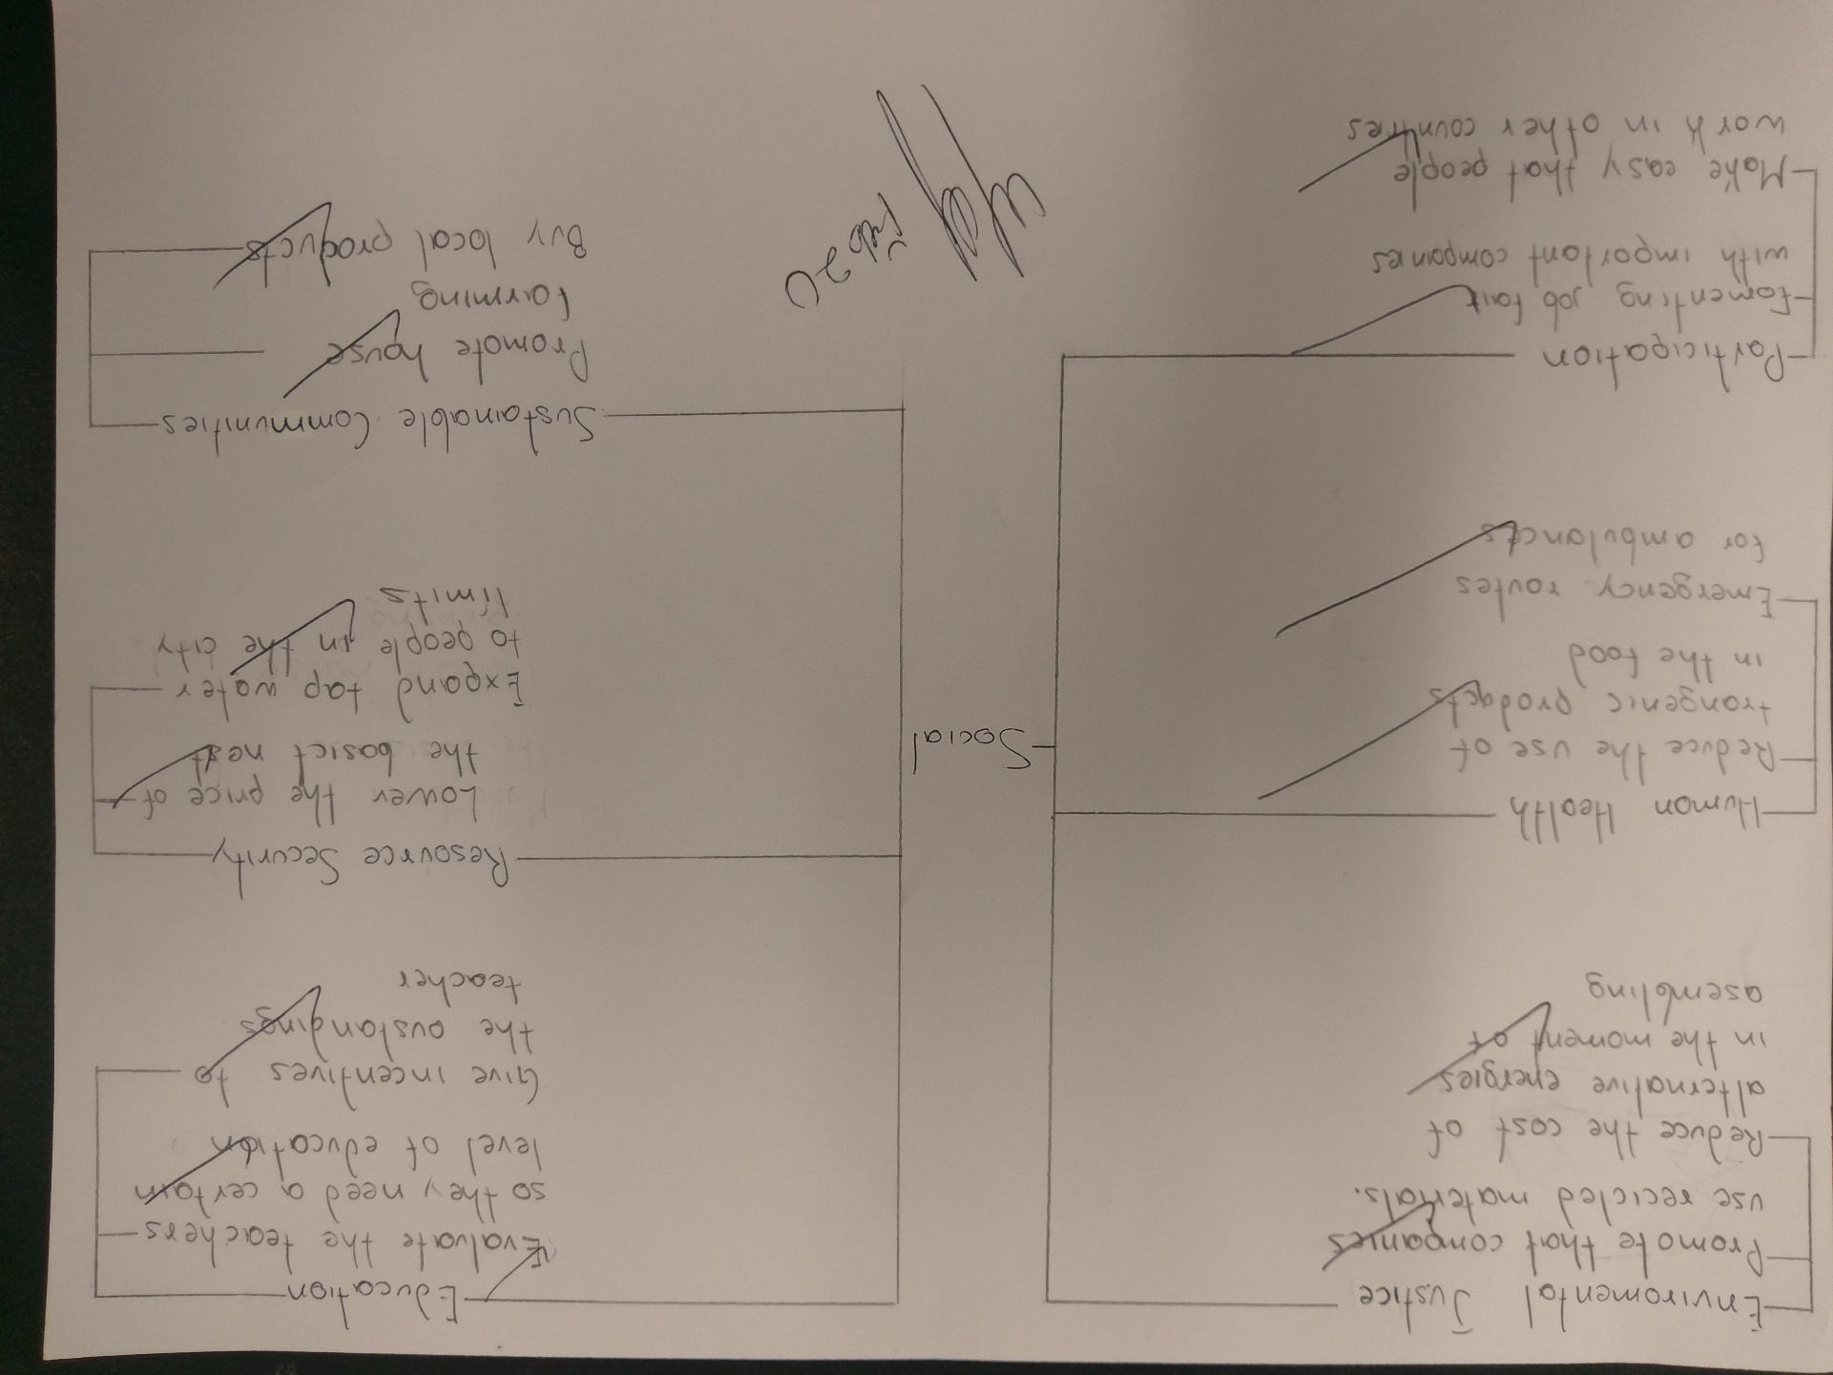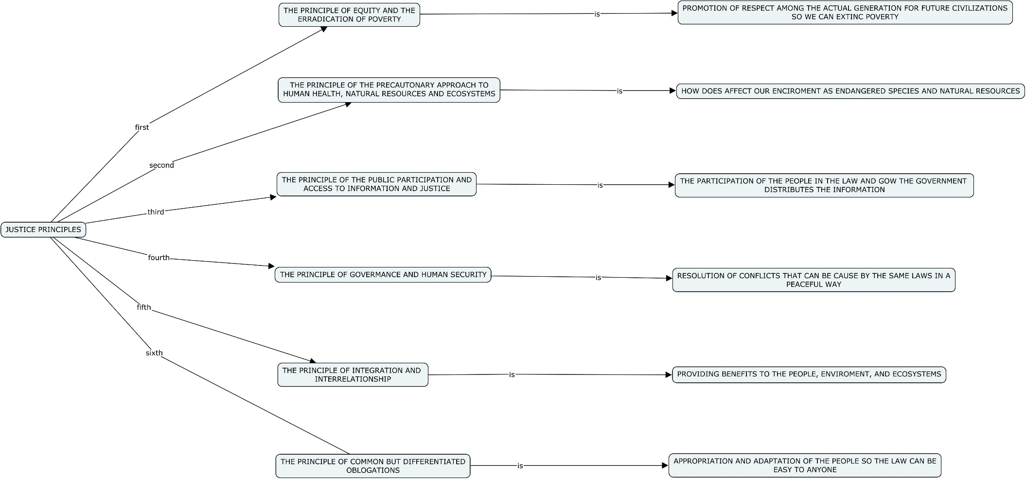

The NOM-161

It is a law in Mexico that promotes the management or and establishes the criteria of the special management trash. This law promotes sustainability not only because it seeks adequate management of waste that has a high potential for pollution to the environment, but also because it contemplates the different routes of action.

According to the document it also contains some of the mentioned justice principles. For example, the integration and participation of people in the process of this law making sure of the fulfillment of this.

Environmental policy in China

The Ministry is tasked with protecting China's air, water, and land from pollution. It is empowered and required by law to implement environmental policies and enforce environmental laws and regulations. Complementing its regulatory role, it funds and organizes research and development. There are 20 offices and departments under this regulation.

According to the justice principles this policy makes sure of the security of the natural resources and human health. Without this policy the conditions in china could be even worse than the ones right now in the country.

<https://www.expoknews.com/3-leyes-mexicanas-que-promueven-el-desarrollo-sostenible/>

<https://en.wikipedia.org/wiki/Environmental_policy_in_China#Policy_jurisdiction>

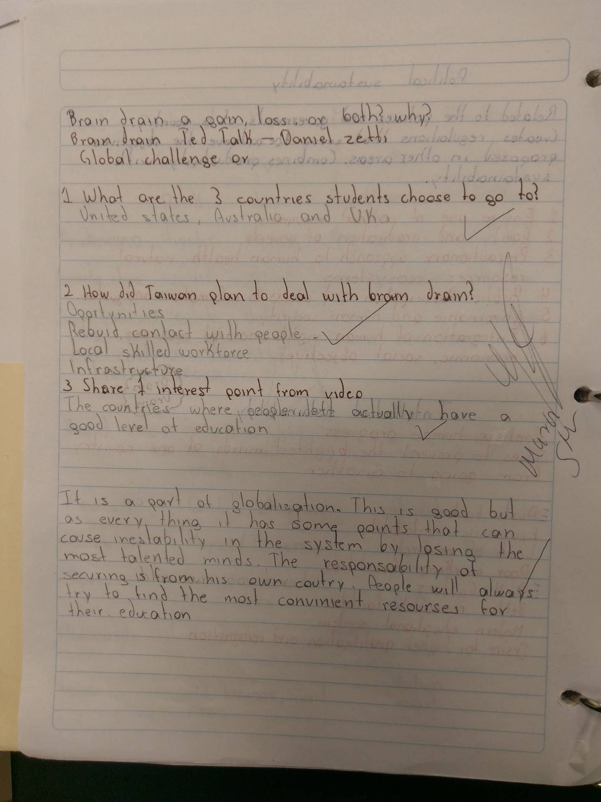

What actions are you going to take to have a more sustainable life?

In the recent days it is more difficult do things to have a sustainable life because the global warming has already affected us. Now in this days the media says to us every day that it is already late and there is no possible thing that we can do to stop global warming. But I do not care, I am going to stop buying processed foods because big part of the damage is this food, that always comes in plastic bags. There are big quantities of trash generated by us. In just one day big cities can produce tons and tons of trash, and this is going to stay more time than the time people is going to live. Another point would be to consume less and less meat. The meat industry is the biggest producer of gases like carbon dioxide because literally all the wastes of the animals produce big amounts of gases. The principal actions that everyone should take are these.